Send Me To Peru!
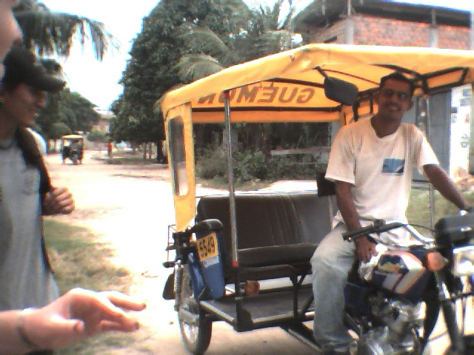

April, 2007
Dear Friend:

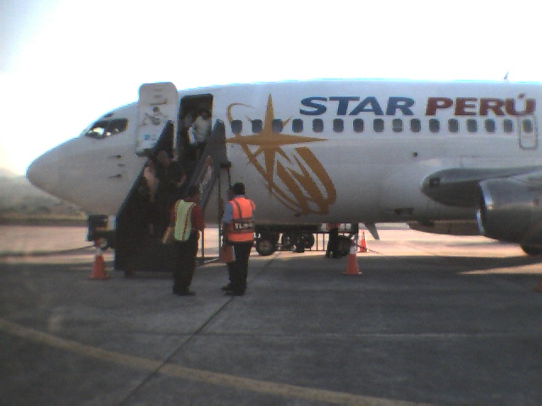
This summer I have an exciting opportunity to go to Peru as part of a mission team from my church, Westwood Baptist Church of Alabaster. We will be doing evangelism and church planting in the city of Cajamarca, Peru. The work will involve going door-to-door to share the gospel through translators, while working with Peruvian churches to help them begin new churches in unreached areas. Home Bible study groups will be formed with the new believers. During our time there we’ll be equipping the Peruvians to continue the work and disciple the new believers after we’re gone.

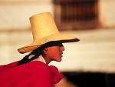
So why have you received this letter? My desire is that you will be a part of my prayer support team and also pray about helping to support me on this trip financially. Let me share more about each of these requests.

First of all, each team member is asked to assemble a team of prayer partners for the trip. We ask you to pray as I prepare and especially the eight days that we are in Peru (June 22-30). Past teams have seen God work in miraculous ways that seem to only be explained by God’s faithfulness in answering the prayers of His children. We desire that God’s attention will be focused on Cajamarca that week like a magnifying glass focuses the sun on a single spot on the ground.

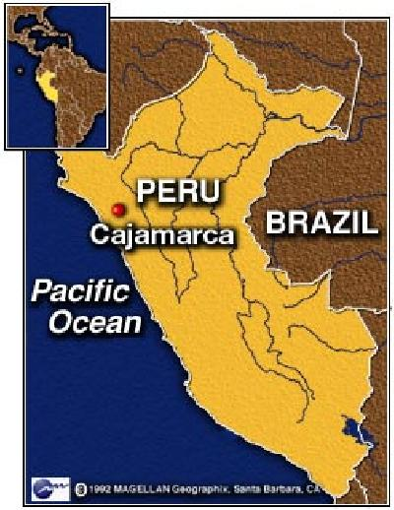
To help you know how to pray specifically, a blog site will be set up for the trip. You will be able to keep up with us through daily postings to the site. Please let me know if you will be a part of my prayer team.

Secondly, each trip participant is encouraged to seek financial support. The cost of the trip is over $2,000 and I’ve stepped out on faith that God will provide the funding. Because we encourage the Peruvians to support and send missionaries to places that need a church, leaders of our trip are encouraging us to set the example by seeking support.. It encourages the Peruvians to know that this method is how we were able to come to their country. The Peruvians are actually supporting and sending people!

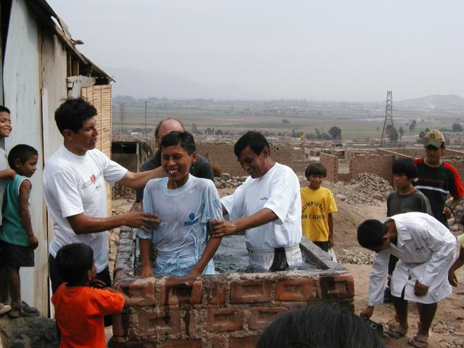
If you feel that God would have you to help financially, please make a check out to Westwood Baptist Church and on the “for” line of the check write “Peru Trip” and my name. You will receive tax deductible credit for this as a charitable contribution. It would be helpful if most funds are received by ___________. Please send the check to me at the following address: _________________________________________________.

Thanks so much for prayerfully considering your involvement in this trip. I look forward to sharing with you what God does this summer!

Yours in Christ!

What it’s really all about… baptism at a new church started by one of our past teams in Peru.

